InsightStream-Navigate the News Landscape
Project submitted to the
SRM University – AP, Andhra Pradesh
for the partial fulfillment of the requirements to award the degree of
Bachelor of Technology
In
Computer Science and Engineering
School of Engineering and Sciences
Submitted by
G.Rakshitha Joyecy - AP23110011475
P.Nikitha- AP23110011539
U.Hema Latha-AP23110011506
K.Akhila-AP23110011422


Under the Guidance of
Himanshu Minshra
Department of Computer Science and Engineering
SRM University–AP
Neerukonda, Mangalagiri, Guntur
Andhra Pradesh – 522 240
[ December, 2025]
INSIGHT STREAM

Introduction:
As global events unfold rapidly across politics, technology, economics, entertainment, and science, staying updated has become essential in everyday life. However, the challenge lies not in the availability of information, but in its management. With countless websites, apps, and social media pages posting news every minute, users often face information overload. Insight Stream addresses this modern challenge by filtering, organizing, and presenting news in a structured format, eliminating the need to switch between multiple platforms.
Unlike traditional news apps that prioritize volume over clarity, Insight Stream focuses on offering a balanced, readable stream of articles. It curates news in a visually appealing card layout, ensuring users can quickly grasp headlines without feeling overwhelmed. The interface has been designed to support smooth navigation, intuitive interactions, and a clean reading experience. By minimizing clutter and emphasizing essential content, Insight Stream enhances both usability and accessibility.
Another key motivation behind developing Insight Stream is the increasing demand for personalized and time-efficient news browsing. Users today expect platforms that adapt to their preferences rather than presenting generic information. The inclusion of a Favourites module supports this need by enabling users to save news articles for later reading. Whether someone is researching a topic, preparing for an interview, or simply collecting stories of interest, this feature helps them keep track of important content effortlessly.
From a technical perspective, Insight Stream demonstrates how modern frontend frameworks and lightweight backend tools can work together to build scalable applications. React.js manages the dynamic rendering of components, ensuring minimal load times and a responsive user interface. Axios simplifies API communication, while JSON Server allows developers to replicate backend operations like storing and retrieving bookmarked articles. Together, these technologies help achieve a fluid, high-performance user experience.
Furthermore, this project reflects the increasing shift towards component-based web development, where applications are built using modular, reusable blocks of code. Each component in Insight Stream—from the news card to the search bar—serves a specific purpose and can be reused or extended as the application grows. This not only improves maintainability but also makes the system future-ready for enhancements such as category filters, user accounts, or AI-driven content recommendations.
Ultimately, Insight Stream serves as both a practical news-reading tool and a strong demonstration of full-stack development principles. It merges design, functionality, and technology to create a platform that simplifies information discovery while showcasing the capabilities of modern web development. By centering the user’s reading experience and incorporating responsive design techniques, Insight Stream becomes an effective solution for anyone seeking organized, reliable, and engaging news content.

Scenario – Based Intro:

Beyond students, consider a working professional who has only a few minutes during a busy schedule to check the latest updates. Opening multiple news portals or scrolling endlessly through social media often results in distraction and wasted time. With Insight Stream, this professional can instantly access crisp, relevant headlines in a structured format. The simplified layout ensures that even during short breaks, users can quickly scan through important stories without unnecessary clutter or advertisements interrupting their experience.
Similarly, imagine a researcher or journalist who needs to monitor developments in a specific field—such as climate change, global markets, or technological innovation. Searching for reliable articles across various sources can be tiring and unproductive. Insight Stream eliminates this difficulty by allowing users to search for topics instantly and retrieve relevant news from trusted sources. The search bar acts as a personalized filter, narrowing down the vast landscape of digital information into a manageable, meaningful list of articles.
For casual readers who check news occasionally, the overwhelming nature of most news applications may discourage regular engagement. Such users often prefer simple, visually appealing designs that present only what is necessary. Insight Stream caters to this audience by offering an intuitive card-based interface that organizes articles neatly with images, short descriptions, and time indicators. This approach transforms news browsing into an enjoyable and effortless activity rather than a complex task.
The bookmarking feature becomes even more valuable in real-life scenarios. Consider a user who discovers an important article but does not have time to read it fully due to a meeting or class. With one click, the article is saved into the Favourites section, ensuring it is never lost in the digital crowd. When the user returns later, the saved article remains easily accessible, helping them stay organized and informed without manually searching for it again.
Insight Stream also addresses the problem of credibility and relevance. Instead of users navigating through sensational or low-quality content, the application integrates reputable news APIs that deliver accurate and current information. This ensures users trust the platform and rely on it for daily updates. Combined with the simple navigation flow, Insight Stream becomes the preferred destination for users seeking fast, relevant, and organized news content.
Ultimately, whether the user is a student, professional, researcher, or casual reader, the application adapts seamlessly to their needs. By reducing time spent searching, organizing, and filtering information, Insight Stream enhances productivity and enables users to stay updated without stress. It transforms the fragmented experience of digital news consumption into a smooth, centralized, and intelligent process that empowers users with information that truly matters.

Target Audience:

Insight Stream is thoughtfully designed to serve a wide and diverse range of users who interact with news and information in different ways. Each audience group has unique needs, and the platform aims to provide all of them with a smooth, organized, and meaningful news-browsing experience.

Students & Competitive Exam Aspirants:
These users need a reliable source of current affairs for exams such as UPSC, SSC, banking, and other academic requirements. Switching across multiple news platforms makes studying harder and more time-consuming. Insight Stream offers a unified, credible, and structured news experience that helps students stay updated without confusion or information overload.

Casual News Readers & Working Professionals:
Casual readers browse news occasionally, while professionals need quick updates during their busy schedules. Both groups prefer simple interfaces that save time. Insight Stream displays concise summaries, engaging visuals, and neatly organized articles, allowing them to read and bookmark important content effortlessly without navigating multiple apps or cluttered websites.

Researchers, Journalists & Analysts:
These users depend on accurate, up-to-date information to study trends, track events, or prepare reports. Insight Stream’s organized feed, search tools, and bookmarking feature help them filter relevant articles and create a personalized collection of news for deeper analysis. The platform enables them to work more efficiently by reducing time spent searching through scattered information sources.

Tech Learners & Web Development Students:
Aspiring developers exploring technologies like React, Axios, and JSON Server can use Insight Stream as a practical example of real-world full-stack development. The app demonstrates concepts such as component-based architecture, API integration, routing, and CRUD operations, making it a valuable learning resource for students building their technical skills.

Project Goals and Objectives:

Insight Stream aims to create a clean, efficient, and user-friendly platform that transforms the way people interact with online news. In a digital environment filled with scattered information, multiple sources, and overwhelming content, the main goal of this project is to provide users with an organized, reliable, and easily navigable news experience. By combining modern web technologies with thoughtful UI design, Insight Stream focuses on delivering clarity, simplicity, and accessibility for all types of readers.
Primary Goals:
- To centralize news from various categories and sources into a single, structured interface.
- To simplify the news-browsing process through clean UI components and intuitive navigation.
- To ensure fast loading, responsive design, and visually appealing layouts for an enjoyable reading experience.
- To allow users to personalize their experience through bookmarking and quick access to saved articles.
- To provide real-time updates by integrating external news APIs for current and relevant information.
Specific Objectives:
● Improve Information Accessibility
To make news easier to discover by presenting concise summaries, high-quality images, and clear headlines that help users quickly understand stories without unnecessary clutter.
● Enhance User Productivity
To reduce the time users spend switching between multiple news platforms, enabling faster reading and better organization through searchable content and a robust bookmark system.
● Support Personalized Reading Habits
To provide features like favourites or saved articles, allowing users to build their own curated list of important stories that they can revisit at any time.
● Demonstrate Modern Web Development Techniques
To showcase full-stack development concepts such as component-based UI design, API fetching, routing, and backend simulation using JSON Server, making the application both practical and educational.
● Deliver a Scalable and Maintainable System
To design the platform so that it can easily grow in the future, supporting additional categories, user accounts, dark mode, or AI-powered recommendations.

Key Features:
Insight Stream includes a set of powerful, user-friendly features designed to make news browsing simple, organized, and time-efficient. Each feature is built to enhance readability, improve accessibility, and provide users with a clean, uninterrupted flow of information.

Latest News Feed
Insight Stream displays a constantly updated feed of the latest headlines from trusted sources. Each news item is presented with an image, a short description, and its publication time, allowing users to quickly understand the context without opening multiple websites. This ensures fast, convenient access to fresh and relevant news.

Search and Topic Filtering
Users who want to find news on a specific subject—such as sports, technology, elections, or science—can simply type a keyword into the search bar. Insight Stream instantly filters articles and shows only the relevant results. This feature helps users avoid information overload and find exactly what they are looking for within seconds.

Bookmarks / Favourites Management
Often, users come across articles they want to read later or revisit. With the Favourites feature, users can bookmark any article with a single click. All saved items appear neatly in a separate section, making it easy to organize and review important news without searching again. This creates a personalized reading space based on the user’s interests.

Clean and Responsive User Interface
Insight Stream offers a simple, elegant, and distraction-free design that enhances readability. The card-based layout, smooth scrolling, and clear text formatting ensure a comfortable experience on mobiles, tablets, and desktops. The interface automatically adjusts to different screen sizes, providing consistent usability everywhere.

Real-Time API Integration
By integrating with a live news API through Axios, Insight Stream fetches real-time updates from global sources. This helps users stay informed with accurate, reliable, and timely content. Whenever new articles are published, they appear instantly in the feed without manual refresh.

Component-Based Architecture (React.js)
The entire platform is built using reusable React components such as NewsCard, SearchBar, Navbar, and Bookmarks. This structure enhances maintainability, makes the project scalable, and ensures smooth performance even as new features are added in the future.

PRE – REQUISITES:
Before building the Insight Stream news application, there are certain essential tools, technologies, and basic skills required. These prerequisites make the development process smooth and help you comfortably work with React, APIs, and modern web development workflows.

Node.js and npm
Node.js allows JavaScript to run outside the browser on your system. It is required for installing packages, running development servers, and managing dependencies for your Insight Stream project.
● Install Node.js along with npm (Node Package Manager) — this is necessary for installing React, Axios, JSON Server, and other libraries.
● Download Node.js: https://nodejs.org/en/download/
● Installation Help: https://nodejs.org/en/download/package-manager/
Node.js powers the entire development setup and allows you to run your project locally with live reloading.

React.js
React.js is the main library used to build the Insight Stream interface. It helps you create reusable UI components, handle dynamic content like live news updates, and build a smooth, responsive user experience.
To create a React project using Vite (which provides fast setup and build times):
- Create a new React app:
npm create vite@latest
● Enter a project name
● Choose the framework: React
● Pick the variant: JavaScript
- Move into the project folder:
cd project-name
- Install dependencies:
npm install
- Start the development server:
npm run dev
Your Insight Stream application will open in the browser at:
http://localhost:5173
React enables dynamic UI updates such as displaying news cards, search results, and bookmarking interactions without refreshing the page.

Basic Web Development Knowledge
You should have basic understanding of:
● HTML — for structuring the layout of the news cards and pages
● CSS — for styling the interface and making it visually appealing
● JavaScript — for handling logic, API communication, and UI interactions
These foundational skills help you understand how the components of Insight Stream work together to display and manage news data.

Version Control (Git & GitHub)
Git helps you track changes, collaborate with others, and maintain different versions of your project. Hosting platforms like GitHub allow you to store and share your Insight Stream project.
● Download Git: https://git-scm.com/downloads
Using Git ensures your project remains safe, organized, and easy to update with new features.

JSON Server (for Backend Simulation)
JSON Server is used as a lightweight backend for storing bookmarked articles in the Favourites section. It allows you to perform GET, POST, and DELETE operations without needing a real database.
To install JSON Server:
npm install -g json-server
To start the backend:
json-server --watch db.json --port 5000
This creates a mock REST API that your React app can interact with.

Development Environment (Code Editor / IDE)
To write and manage your code effectively, you will need a clean, flexible code editor. Popular options include:
● Visual Studio Code: https://code.visualstudio.com/download
● Sublime Text: https://www.sublimetext.com/download
● WebStorm: https://www.jetbrains.com/webstorm/download
These editors provide syntax highlighting, extensions, debugging tools, and built-in terminals, making development faster and more comfortable.

Project Structure:

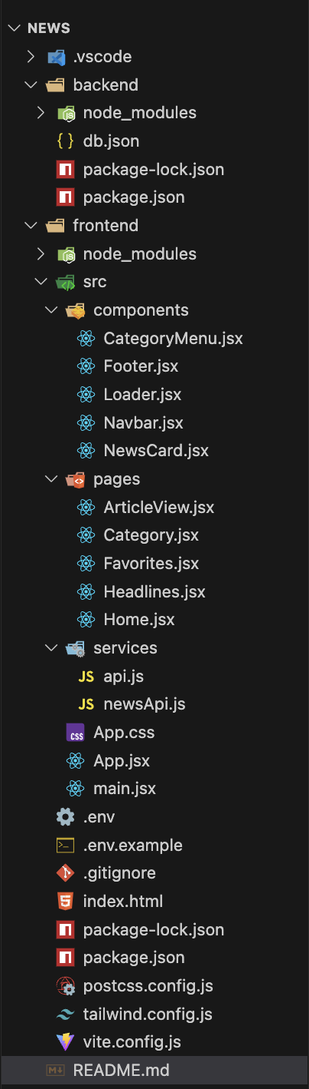

The project structure of Insight Stream is organized in a clean and modular way to ensure that every part of the application is easy to understand, scalable, and simple to maintain. Each folder in the structure has a specific purpose, and together, they form the complete workflow of the news application.
● The src folder is the core of the entire Insight Stream project—it contains all components, pages, services, assets, and styling files required to run the application smoothly.

● components
This folder contains reusable UI elements such as:
- NewsCard.jsx (shows news items)
- Navbar.jsx (top navigation bar)
- BookmarkButton.jsx
These components are used across different pages to keep the UI consistent and reduce repeated code.

● pages
This folder includes full-screen pages that represent the main sections of the Insight Stream application, such as:
- Home.jsx (displays the live news feed)
- Favourites.jsx (shows bookmarked articles)
Each page combines multiple components to create a complete screen for the user.

● services
This folder handles all API integration and backend communication:
- newsAPI.js fetches real-time articles from the news API.
- favouritesAPI.js manages operations like adding or deleting bookmarks from JSON Server.
Keeping API logic separate makes the project clean and easy to maintain.

● assets
Holds images, icons, logos, and other static files used across the application.
(If Tailwind or external icons are used, this folder stores custom visuals.)

● App.jsx
This file controls the routing of the application. It decides which page (Home, Favourites, etc.) should be displayed based on the URL.
It also wraps global layout elements like the Navbar.

● main.jsx
The entry point of the React application.
It connects the React app to the index.html file and initializes rendering.

● db.json
A lightweight mock database used with JSON Server to store all bookmarked/favourite articles.
This file enables backend-like behaviour without needing an actual server.

● package.json, vite.config.js, tailwind.config.js
These configuration files help in:
- Installing and managing dependencies
- Running and building the project
- Styling the application (if Tailwind CSS is used)
- Optimizing development performance through Vite
They ensure that Insight Stream runs efficiently across all environments.

Project Flow
When the user opens Insight Stream, they are greeted with a clean and visually appealing dashboard that displays the latest news articles updated in real time. The Home page shows headlines with images, descriptions, and publication timestamps so users can quickly scan through the most important updates. If they want to save an article for later, they can simply click the bookmark icon, and the article will be stored instantly in the Favourites section.
Users can also make use of the Search feature to filter news based on keywords such as “Technology,” “Sports,” “Politics,” or any specific topic they want to explore. This helps them quickly find relevant information without scrolling endlessly. All features of Insight Stream work together smoothly, giving users a fast, organized, and distraction-free way to stay updated with global events in one place.

Source Link:

https://drive.google.com/file/d/1b1_PXn2lzVlweGwE9GPsEAg2crm48ufQ/view?usp=sharing

Demo Link:

https://1drv.ms/v/c/f74e5034d3779516/IQBnHIHVtrbwSb3djVFwsq_PAYU1OKMrzje1ZVROQqVh0AY?e=Z0izXy

Milestone 1: Project Setup and Configuration

Install Required Tools and Software
Before starting the Insight Stream project, you must install all essential tools, libraries, and dependencies needed to build the website. These tools help you create a responsive UI, fetch live news data, store favourites, and run the project efficiently.

● Tools Used in This Project:

➢ React.js
Used to build the user interface and create reusable components for News Feed, Search Bar, and Favourites. React enables smooth navigation and fast updates without page reloads.

➢ Tailwind CSS
Used to style the entire application with clean, modern, and responsive UI designs. Tailwind makes layout creation faster and ensures uniform styling across the project.

➢ Axios
Used for making API calls to fetch live news articles from external news APIs. It also handles communication with JSON Server for storing bookmarked articles.

➢ JSON Server
Acts as a lightweight backend for saving and managing the user’s favourite articles. It supports operations like GET, POST, and DELETE to mimic real backend behaviour.

➢ Vite
A fast and modern development environment used to set up and run the React project. It speeds up the build time and makes development quicker and smoother.

➢ HTML, CSS & JavaScript
Used for structuring content, designing layouts, and implementing logic inside React components.

● Useful Reference Links:
• React Installation Guide: https://react.dev/learn/installation
• Tailwind CSS Setup: https://tailwindcss.com/docs/installation
• Axios Documentation: https://axios-http.com/docs/intro
• JSON Server Guide: https://www.npmjs.com/package/json-server
• Vite Official Guide: https://vitejs.dev/guide/

Milestone 2: Web Development
Milestone 2 focuses on designing and developing the core structure of the Insight Stream application. During this stage, the main goal is to set up the React environment, configure the routing system, build essential UI components, and prepare the foundation for displaying live news content. This milestone ensures that the application layout, navigation flow, and folder structure are properly organized before integrating APIs and backend operations.

1. Setting Up the React Application
➢ The Insight Stream project is created using Vite, which offers a faster development server, quick updates, and smooth bundling for React applications.
➢ Required libraries such as Tailwind CSS (for modern styling), Axios (for fetching live news data), and React Router (for navigation) are installed to support the main functionalities of the application.
➢ A clean and scalable folder structure is created with directories for components, pages, services, and assets, ensuring that all code is organized and easy to maintain as the application grows.
➢ The main App.jsx file is configured to handle routing, load global styles, render the Navbar and Footer, and identify which page should be displayed depending on the URL.
This file becomes the core controller of the project, connecting pages, components, and navigation to deliver a smooth user experience.
App.jsx Code (For Routing and Layout)

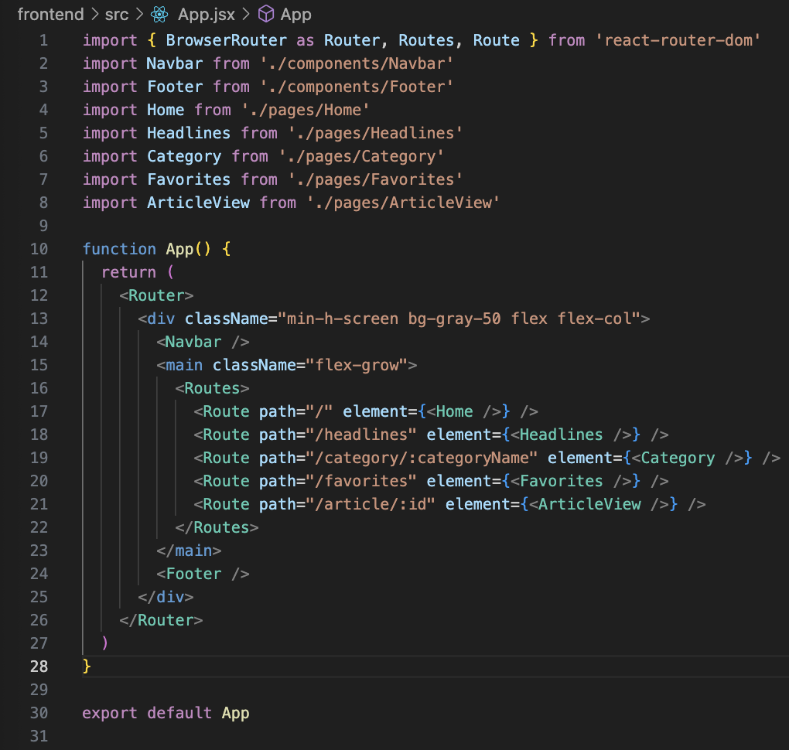

Code Description
● This code defines all the routes and navigation logic of the Insight Stream application using react-router-dom.
● The Navbar component is displayed on every page, helping users navigate between Home, Headlines, Categories, and Favorites.
● The Home page acts as the main dashboard, showing trending articles with images and summaries.
● The Headlines page displays the top and most important news stories retrieved from the API.
● The Category page loads articles dynamically based on the chosen news category.
- For example: /category/technology, /category/sports, etc.
● The Favorites page shows all the articles the user has bookmarked. These are retrieved from JSON Server so users can access them even after refreshing the page.
● The ArticleView page opens when a user clicks on a specific article, showing full details such as the title, image, description, source, and publication date.
● The <main className="flex-grow"> area ensures that the content fills the available height and pushes the footer to the bottom, giving the UI a neat and consistent structure.
● The Footer appears on all pages, providing a clean completion to the layout and additional navigation or branding elements.
● Wrapping the entire application in <Router> allows all navigation to happen smoothly without page reloads, a key requirement for modern single-page applications.
● Overall, this App.jsx file serves as the central connection point for the entire Insight Stream project, controlling page flow, navigation, and layout structure.

2. Design UI Components

UI Design Points
● TailwindCSS integration helps in building clean, responsive UI components quickly using utility classes. It allows Insight Stream to maintain consistent spacing, colors, shadows, and fonts across the entire application.
● Global font smoothing and clean typography make headlines, summaries, and category labels easier to read, improving the overall reading experience for users who browse news for long periods.
● Resetting default browser margins and padding ensures a full-width, clutter-free layout. This gives the app a polished, modern look and makes the news cards align properly on all screen sizes.
● The #root container styling keeps the entire application properly centered and spaced, ensuring that the Navbar, Footer, and content area maintain visual balance across mobile, tablet, and desktop devices.
● Interactive hover effects on the Navbar links, category tabs, and article cards make the UI feel lively and modern. Subtle transitions help guide users without distracting them.
● Card components for news articles use spacing, shadows, and image containers to improve readability and create clear visual grouping. Users can quickly scan titles, dates, and descriptions.
● Responsive grid layouts ensure that news cards automatically adjust from one column on small screens to multiple columns on larger displays, improving usability for all device types.
● Consistent color themes and smooth spacing provide a clean, professional layout that keeps the focus on news content rather than unnecessary design elements.
● Overall, these UI styles work together to create a simple, intuitive, and visually appealing interface, helping users browse news effortlessly and enjoy a cohesive reading experience.

Component Folder:

Navbar.js
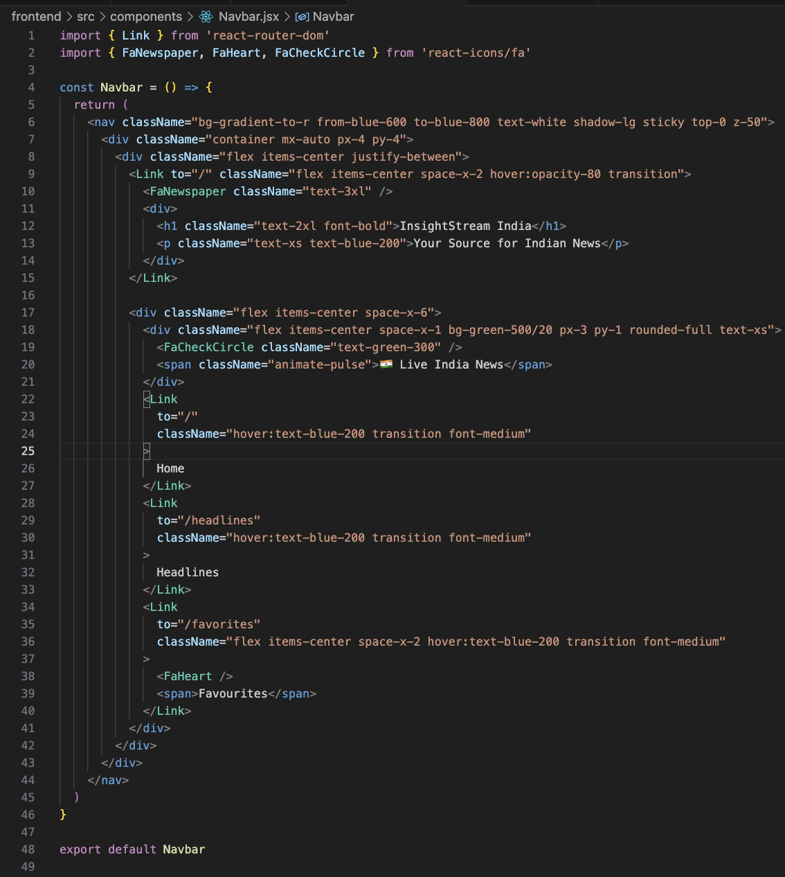

Code Description
This file defines the main navigation bar of the Insight Stream application. It displays important navigation links such as Home, Headlines, Categories, and Favourites, along with the project title and a live-news indicator. The Navbar appears on every page of the website, giving users a consistent and easy way to explore news content.

Key Points

1. Uses React Router for Navigation
The navbar uses:
● Link from react-router-dom
→ Helps navigate between pages without reloading the website.
→ Ensures smooth and fast transitions between Home, Headlines, Categories, and Favourites.
There are no hooks used in this navbar (like useState or useEffect) because it only displays links and does not require dropdowns or user authentication logic.

2. Project Branding and Title Section
At the top-left, the navbar displays:
● A newspaper icon (FaNewspaper)
● The project title: InsightStream India
● A tagline: “Your Source for Indian News”
Tailwind CSS classes such as text-2xl font-bold and text-blue-200 give the title a bold, modern appearance.
Hover effects add interactivity when the user hovers over the title block.

3. Live News Indicator Badge
A special badge shows:
● A pulsing animation (animate-pulse)
● A check icon (FaCheckCircle)
● Text: Live India News
This visually indicates that the platform provides fresh and continuously updated news content.

4. Navigation Links
The navbar includes navigation links structured as:
● Home → "/"
● Headlines → "/headlines"
● Favourites → "/favorites"
Each link uses Tailwind classes like:
● hover:text-blue-200
● transition
● font-medium
These ensure smooth hover animations, proper spacing, and clear readability.
The Favourites link also includes a heart icon (FaHeart) beside the label for better UX clarity.

5. Tailwind CSS Styling
The Navbar uses a gradient background:
bg-gradient-to-r from-blue-600 to-blue-800
This gives the UI a professional, modern, news-portal look.
Additional styling highlights:
● shadow-lg → adds depth
● sticky top-0 z-50 → keeps the navbar fixed while scrolling
● container mx-auto px-4 py-4 → controls spacing
● Flex layouts (flex items-center justify-between) → align items cleanly
These ensure that the Navbar adjusts beautifully on mobile, tablet, and desktop screens.

6. Layout Structure
The Navbar layout is divided into three main parts:
1️⃣ Left side: logo & title
2️⃣ Center: "Live India News" badge
3️⃣ Right side: navigation links (Home, Headlines, Favourites)
This structure keeps navigation intuitive and user-friendly.

7. Overall Role of the Navbar
● Acts as the primary navigation controller for the Insight Stream website
● Provides a clean, responsive, and visually appealing design
● Gives users quick access to news sections
● Enhances user experience with icons and animation
● Maintains consistent branding across all pages

NewsCard.jsx :
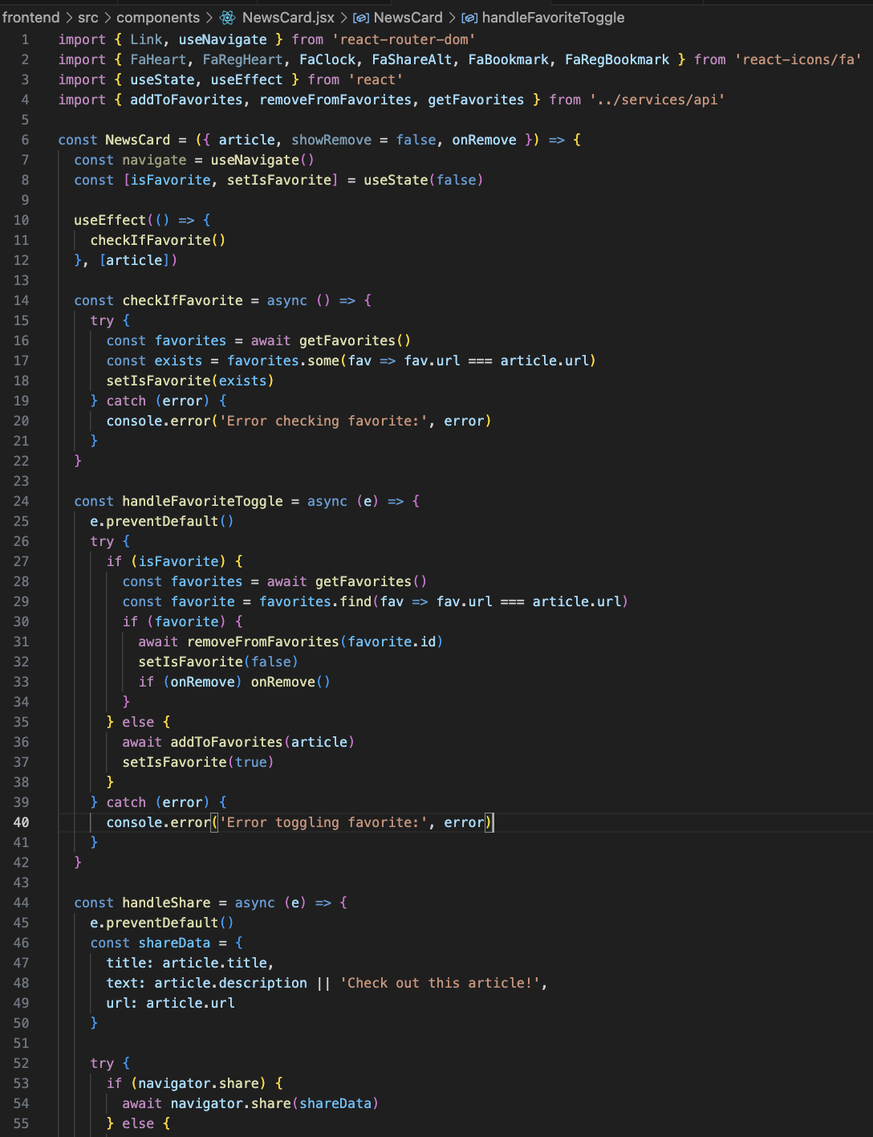
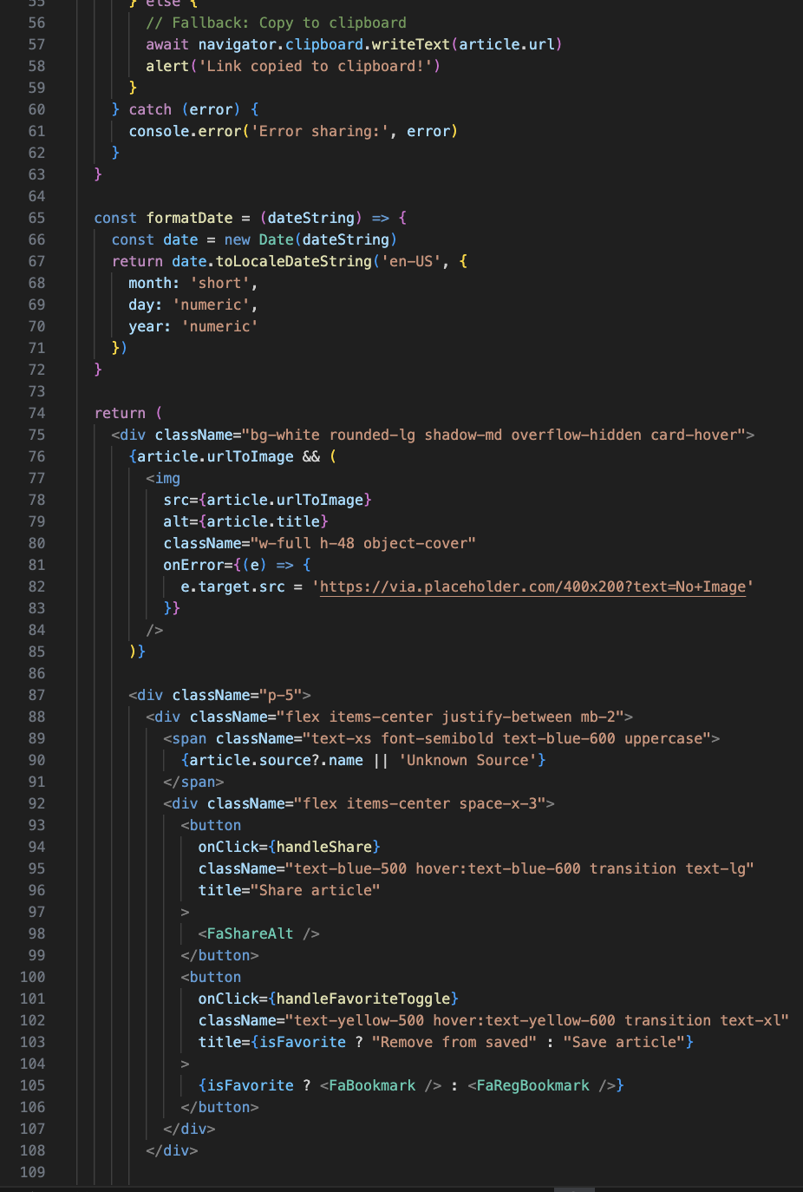
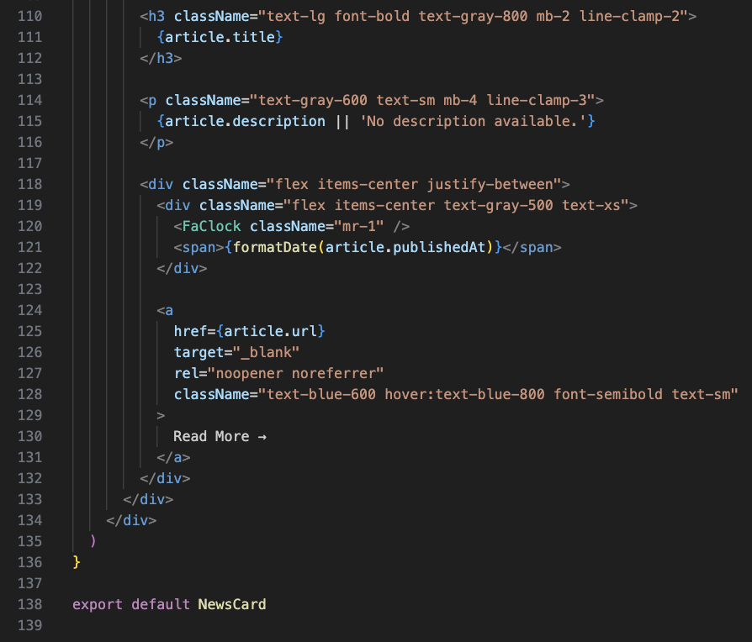

Code Description –
This file defines the NewsCard component, which is one of the most important UI elements in the Insight Stream application. Each card represents a single news article and contains its image, title, description, publish date, source name, and interactive features such as sharing and bookmarking. The component is reusable and dynamically updates based on user actions.

Key Points

1. Uses Essential React Hooks
The component uses multiple React hooks to manage card behaviour:
● useState → tracks whether the article is already added to favourites (isFavorite state).
● useEffect → runs checkIfFavorite() whenever the article changes to keep the UI updated.
● useNavigate (from React Router) → allows navigation to a detailed article page (if needed in future versions).
These hooks make the card dynamic and responsive to user actions.

2. Favorite (Bookmark) Management
This NewsCard connects directly to the backend service through functions imported from ../services/api:
● addToFavorites() → adds the article to JSON Server
● removeFromFavorites() → removes it from favorites
● getFavorites() → checks if the article is already saved
The component:
- Checks whether the article is already favourited.
- Toggles between bookmark and unbookmark icons.
- Removes the card instantly in the Favorites page when onRemove() is triggered.
This gives users a smooth bookmarking experience.

3. Sharing Feature
The component includes a built-in sharing system:
● Uses navigator.share on supported browsers (mobile).
● Falls back to copying the article link to clipboard if sharing isn't supported.
● Displays an alert for successful copy.
This ensures all users can share news easily across devices.

4. Smart Image Handling
● The article image loads at the top of the card using urlToImage.
● If the image fails to load, a placeholder image (No Image) is automatically applied.
● Ensures the card layout remains visually intact even for articles without images.

5. Text Content & Clamping
Inside the card:
● The source name is shown at the top in uppercase.
● The title is bold and limited to 2 lines using line-clamp-2.
● The description is limited to 3 lines using line-clamp-3.
This keeps the card layout clean and prevents long text from disrupting the design.

6. Publish Date Formatting
The function formatDate() converts the API date into a readable format:
Jan 5, 2025
This gives the UI a professional and user-friendly feel.

7. Buttons and Icons
The card uses beautiful icons from react-icons/fa:
● FaShareAlt – share button
● FaBookmark / FaRegBookmark – bookmark toggle
● FaClock – timestamp indicator
Hover effects and Tailwind CSS styling (hover:text-blue-600, transition, text-xl) create a modern, interactive experience.

8. Read More Link
At the bottom:
● A “Read More →” link opens the original article in a new tab.
● Uses target="_blank" for safe browsing.
● Uses Tailwind classes for hover animations and clean styling.

9. Overall Functionality
The NewsCard component:
- Displays all important article information
- Supports bookmarking and unbookmarking
- Allows sharing through system UI or clipboard
- Handles missing images gracefully
- Uses date formatting for clarity
- Keeps UI clean with text clamping and spacing
- Works in both Home and Favorites pages
Overall, this component is the core visual block of Insight Stream, combining content display, user interaction, and backend connectivity in a single reusable element.

CSS/Styling Elements:

App.css

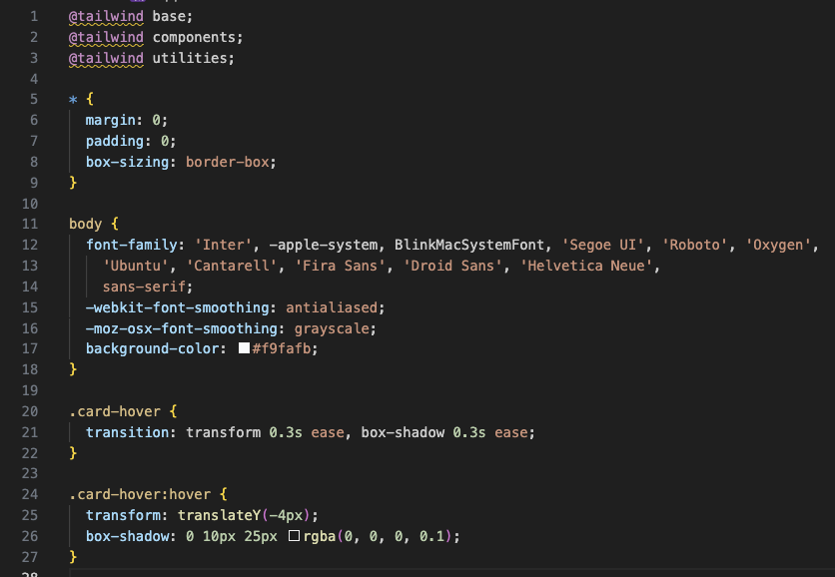

Code Description –
The App.css file is responsible for setting the global design foundation of the Insight Stream application. It defines the global resets, typography settings, background styling, and custom hover animations used across multiple UI components. These styles ensure that the entire app maintains a smooth, modern, and consistent look.

Key Points

1. TailwindCSS Base Layer Imports
At the top of the file:
@tailwind base;
@tailwind components;
@tailwind utilities;
These lines load TailwindCSS into the project and allow the application to use utility classes for layout, spacing, colors, typography, and animations.
They form the foundation for all styling across the React UI.

2. Global CSS Reset
The following rules reset default browser styles:
* {
margin: 0;
padding: 0;
box-sizing: border-box;
}
● Removes unwanted spacing added by browsers
● Ensures consistent sizing of elements
● Gives the layout a clean and controlled appearance
This helps maintain a predictable UI design across all components.

3. Body Styling and Typography
body {
font-family: 'Inter', -apple-system, BlinkMacSystemFont, 'Segoe UI', 'Roboto', 'Oxygen',
'Ubuntu', 'Cantarell', 'Fira Sans', 'Droid Sans', 'Helvetica Neue',
sans-serif;
-webkit-font-smoothing: antialiased;
-moz-osx-font-smoothing: grayscale;
background-color: #f9fafb;
}
This section sets:
● A modern, clean, professional font-family (Inter + system fonts)
● Smooth text rendering for better readability
● A light, subtle background color (#f9fafb) for a soft and minimal UI
This ensures that all text appears sharp and easy to read, important for a news-based website.

4. Custom Card Hover Animation
The .card-hover and .card-hover:hover classes add smooth and elegant animations to news cards:
.card-hover {
transition: transform 0.3s ease, box-shadow 0.3s ease;
}
This sets a transition for hover effects, making UI interactions feel natural.
.card-hover:hover {
transform: translateY(-4px);
box-shadow: 0 10px 25px rgba(0, 0, 0, 0.1);
}
Effects added:
● Card lifts slightly upwards when hovered
● A soft shadow appears around the card
● Gives a polished, interactive feel similar to modern news portals
These effects improve user engagement and make the interface feel dynamic and responsive.

5. Overall Purpose
The App.css file provides:
- Consistent global styling
- Clean typographic hierarchy
- A subtle and elegant color scheme
- Interactive hover animations
- Improved readability across all pages
Together, these styles contribute to Insight Stream’s simple, modern, and visually appealing user experience.
Main.jsx:
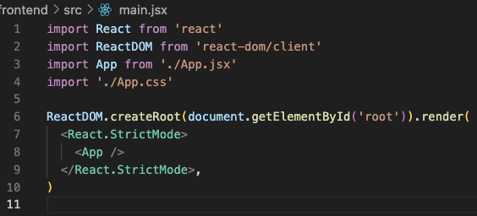

Code Description –
The main.jsx file acts as the entry point of the entire Insight Stream application. It initializes the React environment, connects the app to the HTML root element, and renders the main App component on the screen. This file is crucial because it boots up the application and ensures that all global settings, styles, and components are properly loaded before the user interacts with the site.

Key Points

1. Imports Core React Modules
import React from 'react'
import ReactDOM from 'react-dom/client'
import App from './App.jsx'
import './App.css'
This section imports the essential modules required to start the project:
● React → Enables creating components and using React features
● ReactDOM → Responsible for rendering React components into the actual browser DOM
● App.jsx → The main application component containing routes, Navbar, Footer, and layout
● App.css → Global stylesheet applied across the entire project

2. Connecting React to the Browser
ReactDOM.createRoot(document.getElementById('root')).render(
This line selects the HTML element with the ID 'root' inside index.html.
React then takes control of that element and renders the complete application inside it.
This is how the React app visually appears in the browser.

3. Strict Mode Enabled
<React.StrictMode>
<App />
</React.StrictMode>
Strict Mode helps developers:
● Identify potential problems in the code
● Highlight deprecated React features
● Ensure better performance and long-term maintainability
It does not affect production but is useful during development to catch errors early.

4. Rendering the App Component
The <App /> component is placed inside StrictMode. This loads the entire Insight Stream interface, including:
- Navbar
- Home Page
- Headlines Page
- Category Pages
- Favorites Page
- Footer
- All routing and UI components
This means main.jsx is the file that triggers the rendering of your entire website.

5. Overall Purpose
The main.jsx file:
- Initializes the React application
- Connects it to the HTML root element
- Loads global styles (App.css)
- Wraps the app in StrictMode for development safety
- Triggers the first render of your project
It is the starting point from which the whole Insight Stream application begins running.
Loader.jsx:
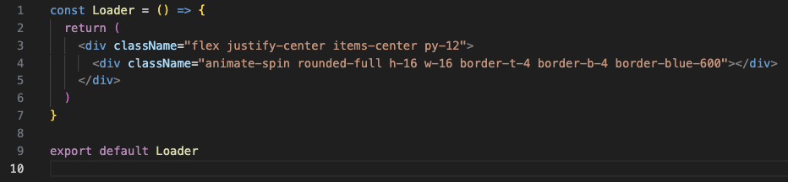

Code Description –
The Loader.jsx component displays a spinning loading animation used throughout Insight Stream whenever data is being fetched from the API. It ensures a smooth user experience by indicating that content is currently loading.

Key Points
● Uses Tailwind CSS classes to center the loader using flex justify-center items-center py-12.
● The spinning circle is styled with animate-spin, rounded shape, and a blue border to match the application's theme.
● The loader is lightweight and reusable, making it ideal for showing progress during API calls such as loading news articles or favorites.
● Helps maintain a polished and responsive UI by preventing blank screens while waiting for data.
Footer.jsx:

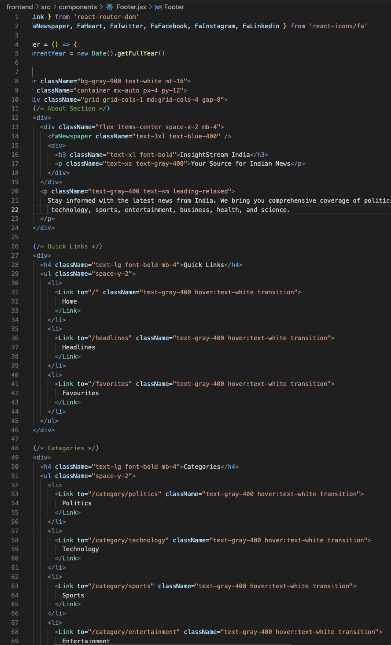
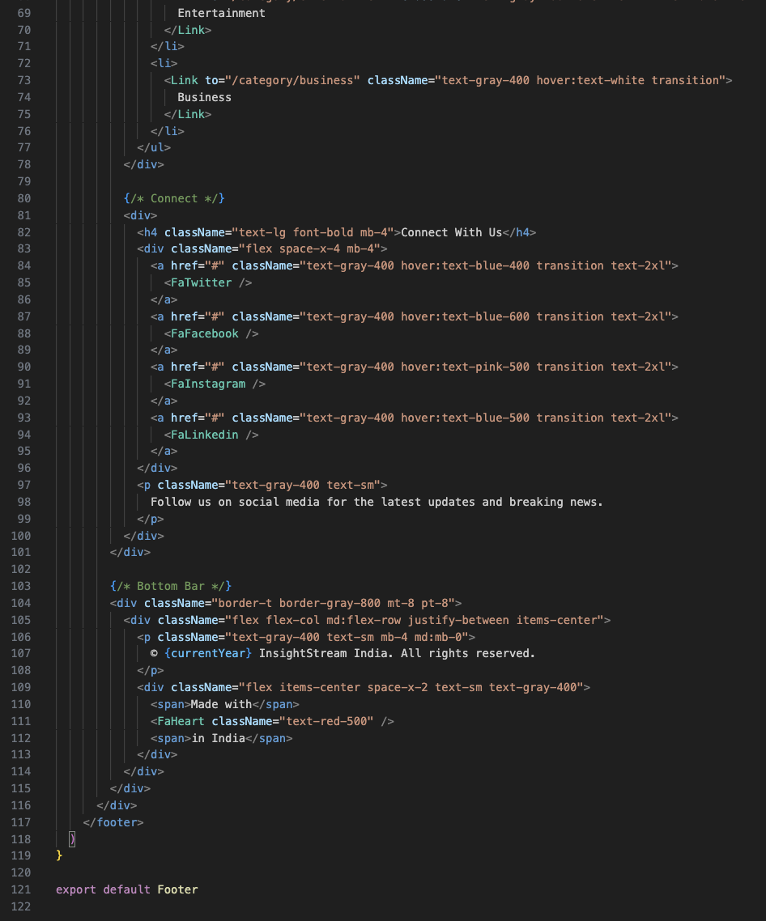

Code Description
The Footer.jsx component creates the bottom section of the Insight Stream website. It provides users with quick navigation links, category shortcuts, social media icons, and branding information. The footer appears on every page, helping improve navigation and giving the app a complete, professional layout.

Key Points
● The footer is divided into four sections: About, Quick Links, Categories, and Connect With Us. This organization makes it easy for users to explore different parts of the platform.
● The About Section includes the app name, logo icon, and a short description to reinforce the purpose of the website.
● Quick Links provide direct navigation to important pages like Home, Headlines, and Favorites, styled with Tailwind for smooth hover effects.
● The Categories section offers shortcuts to major news topics such as Politics, Technology, Sports, Entertainment, and Business.
● The Connect section includes social media icons (Twitter, Facebook, Instagram, LinkedIn) using react-icons, encouraging users to follow or engage with the platform externally.
● A bottom copyright bar shows the current year dynamically and ends with “Made with ❤️ in India,” adding a personal and modern touch.
● Tailwind CSS classes such as bg-gray-900, text-gray-400, grid, and space-y-2 help create a clean, responsive, and visually balanced footer layout that works across all devices.

Api.js:
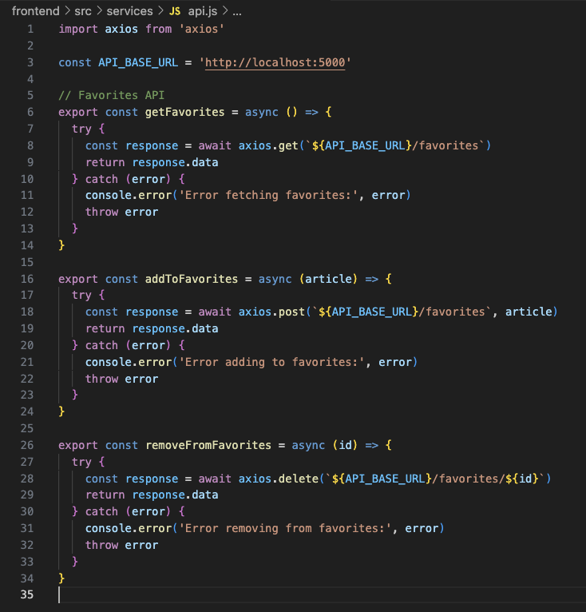

Code Description
The api.js file handles all backend communication for managing favourite articles in Insight Stream. It uses Axios to send HTTP requests to a JSON Server running on http://localhost:5000. By separating API functions into a single file, the project becomes cleaner, easier to maintain, and more reusable across different components.

Key Points
● getFavorites()
Fetches all saved articles from the /favorites endpoint.
Used to check which articles are already bookmarked.
● addToFavorites(article)
Sends a POST request to store a new article in the favorites list.
Allows users to save articles for later reading.
● removeFromFavorites(id)
Deletes a specific article using its ID from the favorites database.
Used when a user removes an article from their saved list.
● Each function uses try–catch to handle errors and logs issues clearly for debugging.
● Centralizing these API methods keeps the codebase organized and ensures components like NewsCard and Favorites can reuse the same backend logic.

Project Execution
After completing the code, run the react application by using the command “npm start” or “npm run dev” if you are using vite.js
Here are some of the screenshots of the application.
Output:
Category Based:
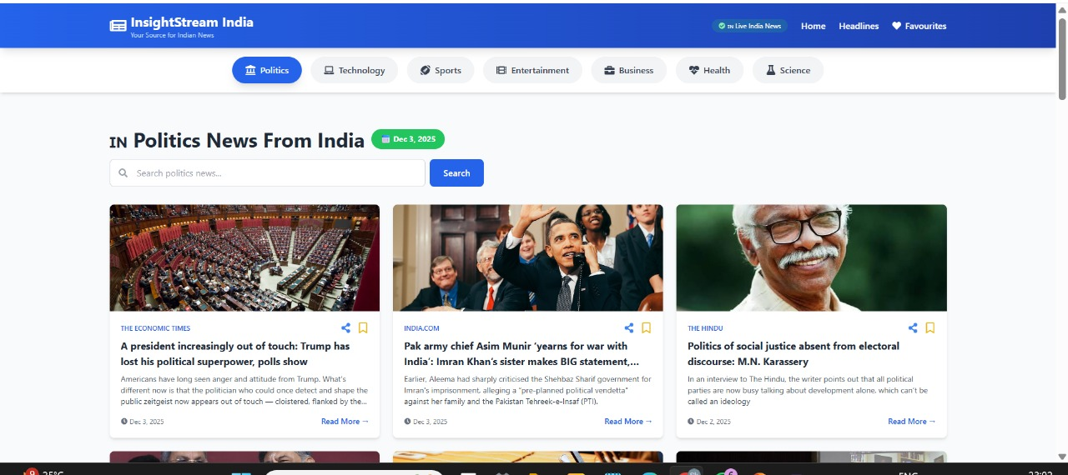

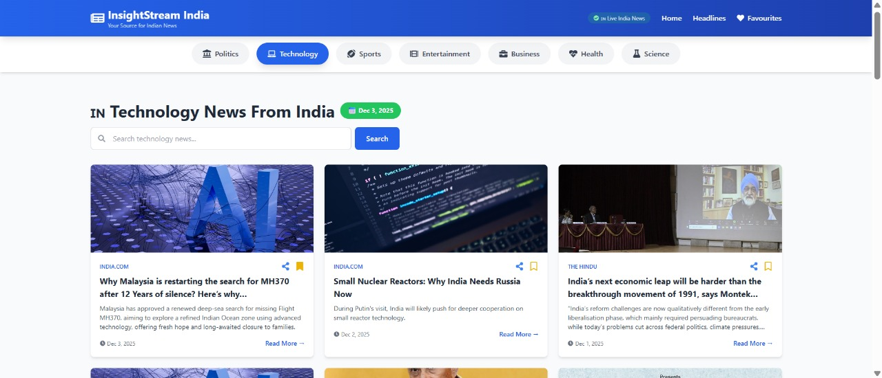

Search Results:
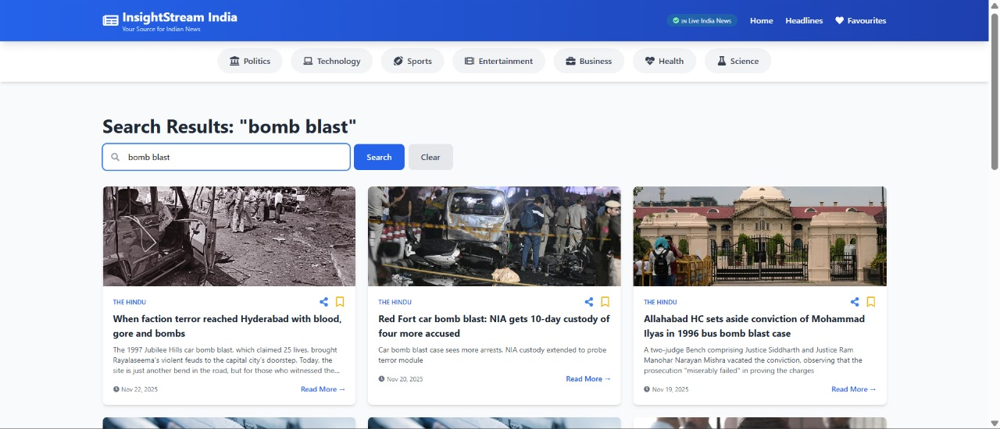

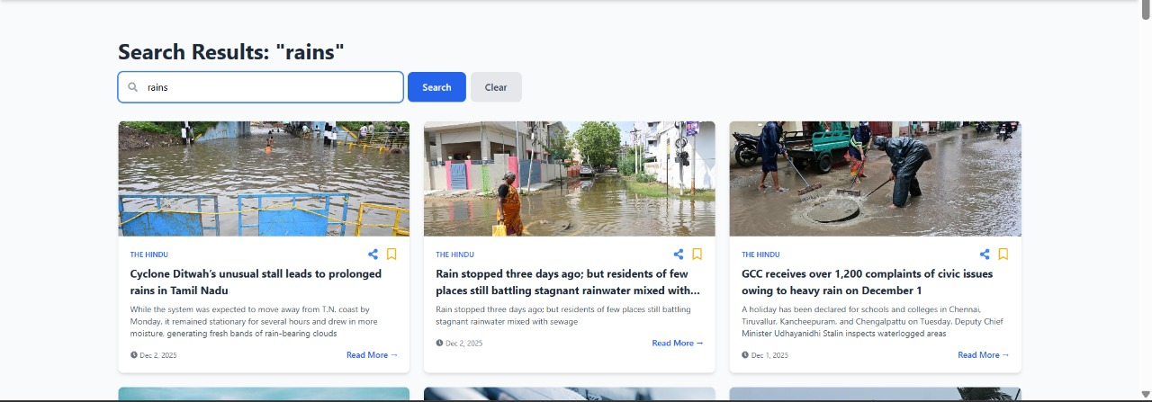
Project Demo link:
https://1drv.ms/v/c/f74e5034d3779516/IQBnHIHVtrbwSb3djVFwsq_PAYU1OKMrzje1ZVROQqVh0AY?e=Z0izXy

*** Happy coding!! ***

